The Eye: Structure and Function
Student worksheet
Use this worksheet with the Eye Structure and Function app on BrainyBlast.com. The light blue boxes are for your answers: click inside one and type, or print the worksheet and write in them.
Name |  | Date |  | Period

Part 1. Explore the eye
Open the Explore tab. Click each structure on the diagram (or choose it from the list). Read Function and Clinical for each one.
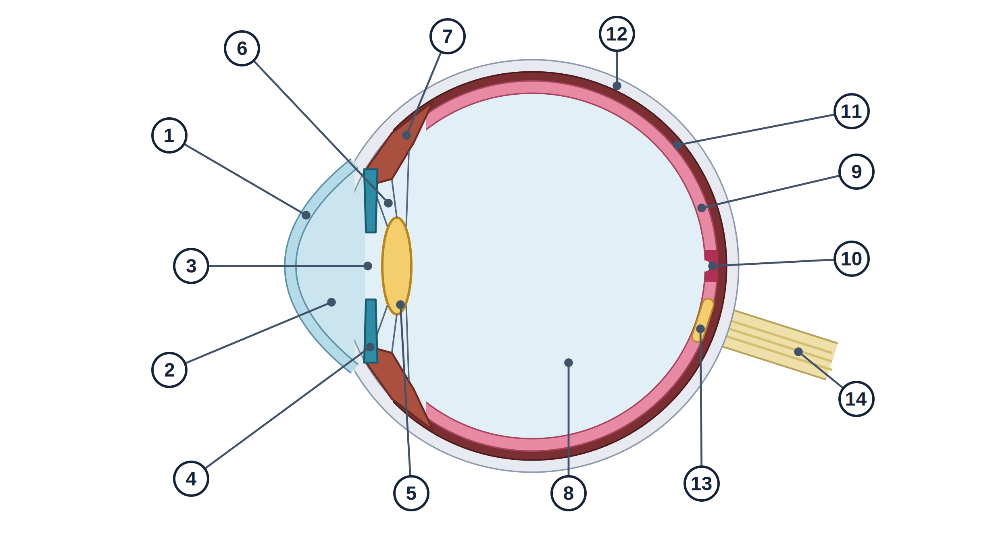
Figure 1. Simplified horizontal section of the right eye. Not to scale.
Label the diagram. Write the name of each numbered structure, the group it belongs to, and what it does in one sentence.
Word bank: aqueous humor, choroid, ciliary body, cornea, fovea centralis, iris, lens, optic disc, optic nerve, pupil, retina, sclera, vitreous humor, zonular fibers (suspensory ligament)
Groups: fibrous tunic, vascular tunic, neural tunic and nerve, lens/opening/fluids
# | Structure | Group | What it does
1
2
3
4
5
6
7
8
9
10
11
12
13
14

Follow the light. Write the six structures light passes through, in order, from the front of the eye to the photoreceptors.
1st | 2nd | 3rd | 4th | 5th | 6th

Part 2. Experiments
Open the Experiments tab and choose each experiment from the menu. For every one: predict first, follow the step card in the app, record what you see, then explain. Finish with the app’s “What did you notice?” question and read its explanation.

Experiment 1: The pupillary light reflex
Predict. When the light goes from dim to bright, what will happen to the pupil?
Record.
Light setting | Pupil size (mm) | Muscle that contracted
Dim
Bright
Explain. Which division of the autonomic nervous system controls each response? Why is a small pupil useful in bright light?

Experiment 2: Accommodation, focusing up close
Predict. How will the lens change shape when you look at something close instead of far away?
Record. Use the colored readout chips on the step card.
Distance | Ciliary muscle | Zonular fibers (suspensory ligament) | Lens shape | Image on retina
Far
Near (30 cm or less)
Explain. Describe the chain of events from ciliary muscle to focused image. Which nerve is involved?

Experiment 3: Nearsightedness (myopia)
Predict. A nearsighted eye looks at a far object. Where will the light focus?
Record.
Situation | Distance | Where the image falls | Sharp or blurred?
Far, no lens | Far
Slide toward Near until it first becomes sharp (no lens)
Far, with the corrective lens | Far
Explain. What kind of lens corrected it, and why does that fix the problem? Why can this person still read comfortably?

Experiment 4: Farsightedness (hyperopia)
Predict. A young farsighted person looks at a distant object. Will the ciliary muscle be relaxed or contracted?
Record.
Situation | Ciliary muscle | Where the image falls | Sharp or blurred?
Far, no lens
Slide toward Near until it first blurs (no lens). Distance when it blurred (cm):
Same near distance, with the corrective lens
Explain. Why might a farsighted student get headaches or tired eyes while reading?

Experiment 5: Presbyopia and reading glasses
Predict. At what age will you no longer be able to focus on something 40 cm away?
Record. Set Distance to 40 cm. Change Age to 20, 50, and 60 (turn the lens off first).
Setting | Focusing reserve (D) | Image at 40 cm | Sharp or blurred?
Age 20, no lens
Age 50, no lens
Age 60, no lens
Age 60, reading lens, 40 cm | 0.7 D
Age 60, reading lens, Far | 0.7 D
Explain. What changes in the eye with age, and why does a reading lens blur distance vision?

Experiment 6: The blind spot (on screen)
Open the Blind spot tab. Cover one eye, look only at the plus, and slide the target until it vanishes. Measure the gap between the plus and the target on your screen with a ruler, and measure the distance from your eye to the screen. Then enter your distance and gap for each eye in the app’s Blind spot tab. When both eyes are recorded, Experiment 6 is complete and counts on your Score sheet.
Eye used | Gap on screen (cm) | Distance, eye to screen, when it vanished (cm) | Angle = arctan(gap ÷ distance)
Right
Left
Your answers will vary with your screen size. If your gap is too small to find the blind spot at a comfortable distance, use the printed card in Part 3 instead, and enter those numbers in the app. If you cannot measure, tick “I tested both eyes but cannot measure” in the app.

Part 3. The printed blind spot card
Print eye-blind-spot-card.pdf at 100% (Actual size) and check that the scale line measures 10 cm. Follow the steps on the card. Hold it about 45 cm from your eyes. Then enter your distance for each eye in the app’s Blind spot tab (the card’s gap is 12 cm) so Experiment 6 counts on your Score sheet. If you used the card instead of the screen test, this is how you finish the experiment.
Test | Distance when it vanished (cm) | Gap (cm) | Angle = arctan(12 ÷ distance)
A. Right eye, dot |  | 12.0
B. Left eye, dot |  | 12.0
C. Right eye, line with a gap |  | 12.0
Questions.
1. In test C, what did the line look like when the gap was on your blind spot? What is your brain doing?
2. Is your blind spot on the nasal or temporal side of your visual field? Where is the optic disc on the retina? Why are they on opposite sides?

Part 4. Quiz review
Take both quizzes in the Quiz tab until you are happy with your best scores.
Quiz | Best score (%) | Date
Multiple choice
Find it on the diagram
Structures I missed. List the structures on the Quiz tab’s “Structures to review” list, or the ones you remember missing.
Fix them. Pick two structures you missed. Write the function in your own words.
Structure | Correct function, in my own words

Part 5. Clinical connections
Use the Clinical section for each structure in the Explore tab. Complete the table.
Condition | Structure affected | What goes wrong | Effect on vision
Cataract
Glaucoma
Myopia
Presbyopia
Macular degeneration
Retinal detachment

Part 6. My score
Open the Score sheet tab and copy your numbers here.
Quiz (%) | Explore (%) | Experiments (%) | Overall (%)
One thing that surprised me:
One question I still have:

